# **CSC 431** OneStat and WARLeagues Software Requirements Specification (SRS)

**Team 10**

|  |  |
| --- | --- |
| Nolan McDermott | Scrum Master, Concept Manager |
| Zach Fulton | Team Member, Implementation Manager |
| Talon Smith | Team Member, Design Manager |

# Version History

|  |  |  |  |
| --- | --- | --- | --- |
| Version | Date | Author(s) | Change Comments |
| 1.0 | 2/21/2021 | Nolan | First Draft |
| 2.0 | 3/8/2021 | Nolan/Zach/Talon | Added Use Case Diagrams, constraints, more non-functional requirements. |
| 2.1 | 3/9/2021 | Nolan/Zach/Talon | Added a few constraints, tweaks |
| 3.0 | 4/13/2021 | Zach | Fixes Based on TA Feedback |
| 3.1 | 4/29/2021 | Nolan | Final fixes |

# Table of Contents

1. System Requirements 7

1.1 Functional Requirements 7

1.1.1 Player Comparison 7

1.1.2 OneStat Leaderboard 7

1.1.3 Custom Leaderboard Creation 7

1.1.4 Statistic Dictionary 8

1.1.5 User Signup System 8

1.1.6 User Authentication System 8

1.1.7 WARLeague Creation 8

1.1.8 WARLeague Drafting 9

1.1.9 WARLeague Standings 9

1.2 Non-Functional Requirements 9

1.2.1 Fast Player Comparisons 9

1.2.2 Visually Pleasing Leaderboards 9

1.2.3 Up-to-date Standings 10

1.2.4 Information Encryption 10

2. System Constraints 11

2.1 Tool Constraints 11

2.1.1 MySQL 11

2.1.2 PyMySQL 11

2.2 Language Constraints 11

2.2.1 Python Based 11

2.2.2 SQL Database 11

2.3 Platform Constraints 11

2.3.1 IOS Support 11

2.3.2 Desktop Support 12

2.3.3 Android Support 12

2.4 Hardware Constraints 12

2.4.1 Memory 12

2.4.2 Processor 12

2.5 Network Constraints 12

2.5.1 Network Connection 12

2.6 Deployment Constraints 12

2.6.1 Coordinated Release 12

2.7 Transition & Support Constraints 13

2.7.1 PayPal Donations 13

2.8 Budget & Schedule Constraints 13

2.8.1 500 Hour Maximum 13

2.8.2 $500 Budget 13

2.8.3 May 9th Deadline 13

3. Requirements Modeling 14

3.1.1 OneStat Use Case 14

3.1.2 WARLeagues Use Case 15

3.1.3 Stats Dictionary Use Case 16

4. Evolutionary Requirements 17

4.1 Functional Requirements 17

4.1.1 Chart Creation 17

4.2 Non-Functional Requirements 17

4.2.1 Database Creation 17

4.2.2 Sport Expansion 17

# Table of Tables

Table of Contents – III

Table of Tables – V

Table of Figures - VI

# Table of Figures

3.1.1 OneStat Use Case 14

3.1.2 WARLeagues Use Case 15

3.1.3 Stats Dictionary Use Case 16

### System Requirements

#### Functional Requirements

##### Player Comparison

|  |  |
| --- | --- |
| Title | Player Comparison |
| Description | User wants to compare the stats of 2 players |
| Priority | 1 |
| Precondition(s) | User must be authenticated |
| Basic Flow | 1. User chooses the “player comparison” option. 2. User enters 2 names into player comparison prompt. 3. User is presented with a comparison of the default stats. |
| Postconditions(s) | User can change players or statistics presented |
| Use Case Diagram | 3.1.1 |

##### OneStat Leaderboard

|  |  |
| --- | --- |
| Title | Leaderboard |
| Description | User wants to view the leaders of the default stats. |
| Priority | 0 |
| Precondition(s) | None (homepage, no authentication needed) |
| Basic Flow | 1. User selects “OneStat leaderboard” option. 2. User is presented with a comprehensive leaderboard of the default statistics of all qualified players from the most recent year. |
| Postconditions(s) | User can change order, year, position or team statistics presented |
| Use Case Diagram | 3.1.1 |

##### Custom Leaderboard Creation

|  |  |
| --- | --- |
| Title | Custom Leaderboard Creation |
| Description | User wants to create a leaderboard with specific statistics |
| Priority | 1 |
| Precondition(s) | User must be authenticated |
| Basic Flow | 1. User chooses the “create custom leaderboard” option. 2. User chooses the stats, position, team, year for the leaderboard to present. 3. User is presented with his custom leaderboard |
| Postconditions(s) | User can change order, year, position, or team statistics presented |
| Use Case Diagram | 3.1.1 |

##### Statistic Dictionary

|  |  |
| --- | --- |
| Title | Statistic Dictionary |
| Description | User wants to see definitions and explanations of statistics. |
| Priority | 3 |
| Precondition(s) | User must be authenticated |
| Basic Flow | 1. User chooses the “statistic dictionary” option. 2. User is presented with a cumulative list of definitions and examples of the statistics. |
| Postconditions(s) | User can navigate to other view |
| Use Case Diagram | 3.1.3 |

##### User Signup System

|  |  |
| --- | --- |
| Title | User Signup System |
| Description | User creates a username and password for the software. |
| Priority | 0 |
| Precondition(s) | N/A |
| Basic Flow | 1. User enters a username and password for a personal account. 2. The system stores the information for future authentication. |
| Postconditions(s) | User can navigate to other view |
| Use Case Diagram | 3.1.1 |

##### User Authentication System

|  |  |
| --- | --- |
| Title | User Authentication System |
| Description | User logs in by matching username and password to existing account. |
| Priority | 0 |
| Precondition(s) | N/A |
| Basic Flow | 1. User enters their username and password to by authenticated. 2. If the system has a match for the user entry, the user is authenticated. |
| Postconditions(s) | User can navigate to other view |
| Use Case Diagram | 3.1.1 |

##### WARLeague Creation

|  |  |
| --- | --- |
| Title | WARLeague Creation |
| Description | User wants to create a fantasy WARLeague |
| Priority | 2 |
| Precondition(s) | User must be authenticated |
| Basic Flow | 1. User chooses “Create WARLeague.” 2. User fills out league information. 3. User can invite other players to join the league. 4. User can draft. |
| Postconditions(s) | User can navigate to other views |
| Use Case Diagram | 3.1.2 |

##### WARLeague Drafting

|  |  |
| --- | --- |
| Title | WARLeague Drafting |
| Description | User wants to draft teams for his WARLeague |
| Priority | 2 |
| Precondition(s) | N/A |
| Basic Flow | 1. User chooses “Draft.” 2. User and any other members choose players to fill out their team. |
| Postconditions(s) | User can navigate to other views |
| Use Case Diagram | 3.1.2 |

##### WARLeague Standings

|  |  |
| --- | --- |
| Title | WARLeague Standings |
| Description | User wants to view the standings for his WARLeague |
| Priority | 2 |
| Precondition(s) | N/A |
| Basic Flow | 1. User chooses “View Standings.” 2. User is presented with the standings of the WARLeague |
| Postconditions(s) | User can navigate to other views |
| Use Case Diagram | 3.1.2 |

#### Non-Functional Requirements

##### **Fast Player Comparisons**

|  |  |
| --- | --- |
| Title | Fast player comparisons |
| Description | When the player comparison feature is used, it returns the results in under a minute |
| Priority | 0 |
| Applicable FR(s) | 1.1.1 Player comparisons |

##### **Visually Pleasing Leaderboards**

|  |  |
| --- | --- |
| Title | Visually pleasing leaderboards |
| Description | Leaderboards should have clear and consistent formatting |
| Priority | 3 |
| Applicable FR(s) | 1.1.2 OneStat Leaderboard, 1.1.3 Custom Leaderboard Creation |

##### **Up-to-date Standings**

|  |  |
| --- | --- |
| Title | Up-to-Date Standings |
| Description | The WARLeague standings are updated to reflect the most recent in game results. |
| Priority | 3 |
| Applicable FR(s) | 1.1.9 WARLeague Standings |

##### **Information Encryption**

|  |  |
| --- | --- |
| Title | Information Encryption |
| Description | The user’s information (Username, Password) is store under encryption to ensure safekeeping |
| Priority | 2 |
| Applicable FR(s) | 1.1.5 User Signup System, 1.1.6 User Authentication System |

### System Constraints

#### Tool Constraints

##### **MySQL**

|  |  |
| --- | --- |
| Title | MySQL |
| Description | MySQL is used for the OneStat database |
| Priority | 0 |

##### **PyMySQL**

|  |  |
| --- | --- |
| Title | PyMySQL |
| Description | PyMySQL is used for by the software to interact with the database and the UI. |
| Priority | 0 |

#### Language Constraints

##### **Python Based**

|  |  |
| --- | --- |
| Title | Python Based |
| Description | The core function of the program is written in python for easy updating, readability, and functionality. |
| Priority | 0 |

##### **SQL Database**

|  |  |
| --- | --- |
| Title | SQL Database |
| Description | The OneStat Database will be in SQL for fast and easy to write queries of large data. |
| Priority | 0 |

#### Platform Constraints

##### **IOS Support**

|  |  |
| --- | --- |
| Title | IOS Support |
| Description | The application can run on IOS |
| Priority | 2 |

##### **Desktop Support**

|  |  |
| --- | --- |
| Title | Desktop Support |
| Description | The application can run on Desktop |
| Priority | 0 |

##### **Android Support**

|  |  |
| --- | --- |
| Title | Android Support |
| Description | The application can run on Android |
| Priority | 4 |

#### Hardware Constraints

##### **Memory**

|  |  |
| --- | --- |
| Title | Memory Requirement |
| Description | Must be able to run on a platform with 5 GB DDR3 RAM |
| Priority | 0 |

##### **Processor**

|  |  |
| --- | --- |
| Title | CPU requirement |
| Description | Must be able to run using an Intel Pentium i5 processor or comparable |
| Priority | 0 |

#### Network Constraints

##### **Network Connection**

|  |  |
| --- | --- |
| Title | Network Connection Requirement |
| Description | Software must work with any network connection |
| Priority | 0 |

#### Deployment Constraints

##### **Coordinated Release**

|  |  |
| --- | --- |
| Title | Coordinated Release |
| Description | All versions are released at the same time |
| Priority | 3 |

#### Transition & Support Constraints

##### **PayPal Donations**

|  |  |
| --- | --- |
| Title | PayPal Donations |
| Description | Software accepted PayPal Donations for support in server costs |
| Priority | 5 |

#### Budget & Schedule Constraints

##### **500 Hour Maximum**

|  |  |
| --- | --- |
| Title | 500 Hour Maximum |
| Description | The project must be completed in under 500 hours of work |
| Priority | 1 |

##### **$500 Budget**

|  |  |
| --- | --- |
| Title | $500 Budget |
| Description | Project must be completed for under $500 |
| Priority | 0 |

##### **May 9th Deadline**

|  |  |
| --- | --- |
| Title | May 5th deadline |
| Description | Project must be completed by May 5th |
| Priority | 0 |

### Requirements Modeling

##### **OneStat Use Case**

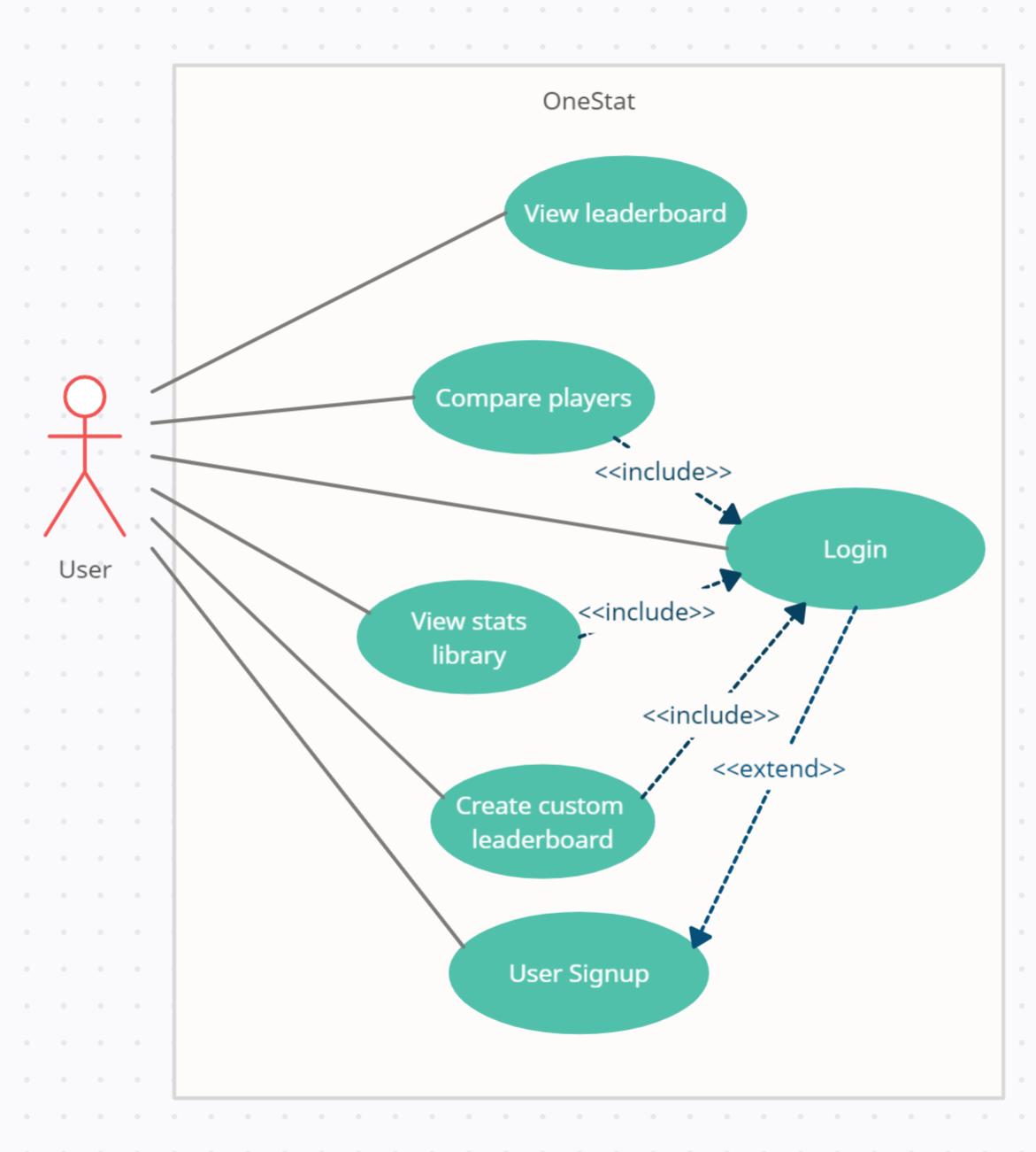

##### **WARLeagues Use Case**

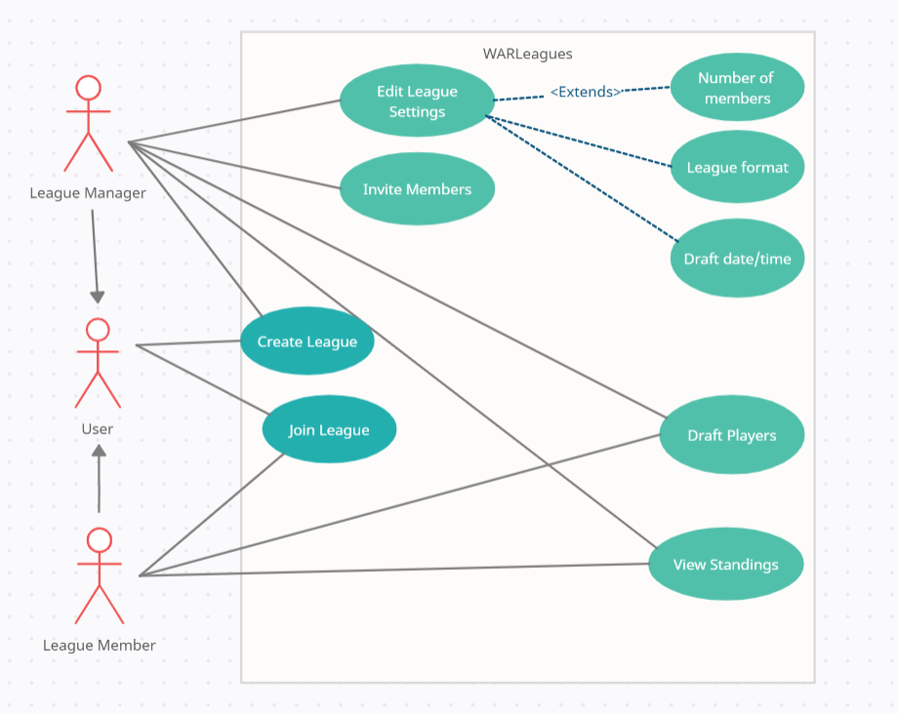

##### Stats Dictionary Use Case

### Evolutionary Requirements

#### Functional Requirements

##### **Chart Creation**

|  |  |
| --- | --- |
| Title | Chart Creation |
| Description | Users will be able to generate their own charts and graphs based on site data. |
| Priority | 4 |
| Precondition(s) | User is authenticated |
| Postconditions(s) | Chart displayed |
| General flow | 1. User chooses stat and clicks “Create chart.” 2. Chart is created and presented to the user. |

#### Non-Functional Requirements

##### **Database Creation**

|  |  |
| --- | --- |
| Title | Creating Backend Database for OneStat |
| Description | We would use a DBaaS to not rely on third parties for data |
| Priority | 3 |
| Applicable FR(s) | 1.1.2 OneStat Leaderboard |

##### **Sport Expansion**

|  |  |
| --- | --- |
| Title | Creating OneStat for other sports |
| Description | Once the baseball OneStat is up and running, expand into building specialized statistics for other sports. |
| Priority | 5 |
| Applicable FR(s) | 1.1.2 OneStat Leaderboard, 1.1.4 Statistic Dictionary |